Armitage attack on Windows XP
  - (script-kiddie ATTACK)
Mubeen Khan | Ethical Hacking and Governance

Contents
1. Executive Summary 1
2. Introduction 2
2.1 Lab Objective and Learning Outcome 2
2.2 Tools and Technologies used 2
2.3 Disclaimer 3
3. Lab Environment Setup 3
3.1 Kali Linux Virtual Machine Setup 3
3.2 Windows XP Victim Machine setup 4
3.3 Network Configuration (NAT network) 4
4. Methodology: The Attack Chain 8
4.1 Step 1: Reconnaissance 8
4.2 Step 2: Vulnerability Analysis 9
4.3 Step 3: Exploitation 10
4.4 Step 4: Post-Exploitation 12
5. Results & Analysis 14
6. Defense and Mitigation strategies 14
7. Conclusion 14
7.1 Key Learnings 14
7.2 Ethical Hacker’s mindset 14

Executive Summary
This report is about using a GUI based script-kiddie attacking tool from Kali Linux called Armitage. In this lab we will learn how to identify vulnerabilities of the victim machine and gain access into the victim machine to perform exploitation attacks such as keylogging, screen capturing, modification of files, privilege escalation with meterpreter. This lab will be carried out in a controlled, sandboxed virtual environment.
The core methodology involved a structured attack chain: initial reconnaissance via an NMAP scan to identify the target, vulnerability analysis using Armitage’s automated tools, and the successful exploitation of the MS08-067 NetAPI vulnerability. This exploit provided remote administrative access to the victim machine, enabling post-exploitation activities such as remote desktop surveillance and keylogging through a meterpreter session.
The purpose of this exercise was to demonstrate how automated “script-kiddie” tools can be a significant threat. The offensive perspective was used to inform defensive strategies, emphasizing the critical importance of proactive patch management, principle of least privilege as fundamental security controls.
Lastly, this lab served as a powerful practical lesson: understanding the tools and techniques of attackers and help in gaining the skills to think from attackers’ point-of-view and foster a security analyst mindset.

2. Introduction

2.1 Lab Objective and Learning Outcome
The objective of this Lab is to configure a virtual lab environment with Kali Linux (Attacker) and Windows XP (Victim) on an isolated NAT network. We will then execute a simulated attack using the Armitage GUI to exploit the MS08-067 vulnerability and perform post exploitation activities on the compromised host using Meterpreter.
MS08-067 is a critical remote code execution vulnerability in the server service on Microsoft Windows System. It is one of the most famous and widely exploited vulnerabilities in history. CVE Identifies: CVE-2008-4250. This vulnerability could be exploited without needing a username or password.
Script-Kiddie Attack is the attacks carried out by hackers who use pre-written scripts to carryout cyberattacks, these types of hackers lack programming skills and expertise in hacking and use the pre-made tools to launch cyberattacks.
Learning Outcomes
At the end of this lab, I was able to gain practical experience with automated penetration testing tools (Armitage), I gain an insight of post-exploitation techniques and their impact and acquired the knowledge of implementing security measures from an offensive action.

2.2 Tools and Technologies used
Virtualization Software: Oracle VirtualBox
Attacker OS: Kali Linux 2025
Victim OS: Microsoft Windows XP professional
Penetration Testing Tool: Armitage (GUI for Metasploit)
Payload: Meterpreter
Vulnerability: MS08-067
Reconnaissance Tool: Nmap

2.3 Disclaimer
All activities described in this report were performed within a strictly isolated and self-contained virtual lab environment. The tools and techniques were used solely for educational purposes to understand attack methodologies and strengthen defensive skills. Unauthorized testing against systems without explicit permission is illegal and unethical.

3. Lab Environment Setup

3.1 Kali Linux Virtual Machine Setup
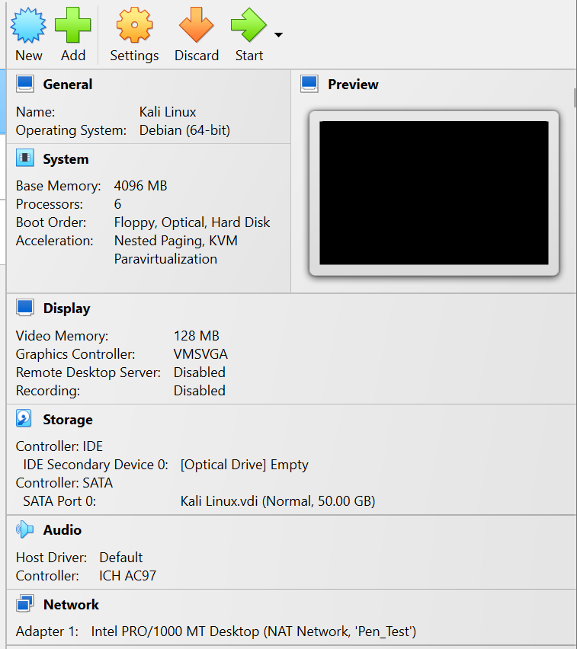

3.2 Windows XP Victim Machine setup
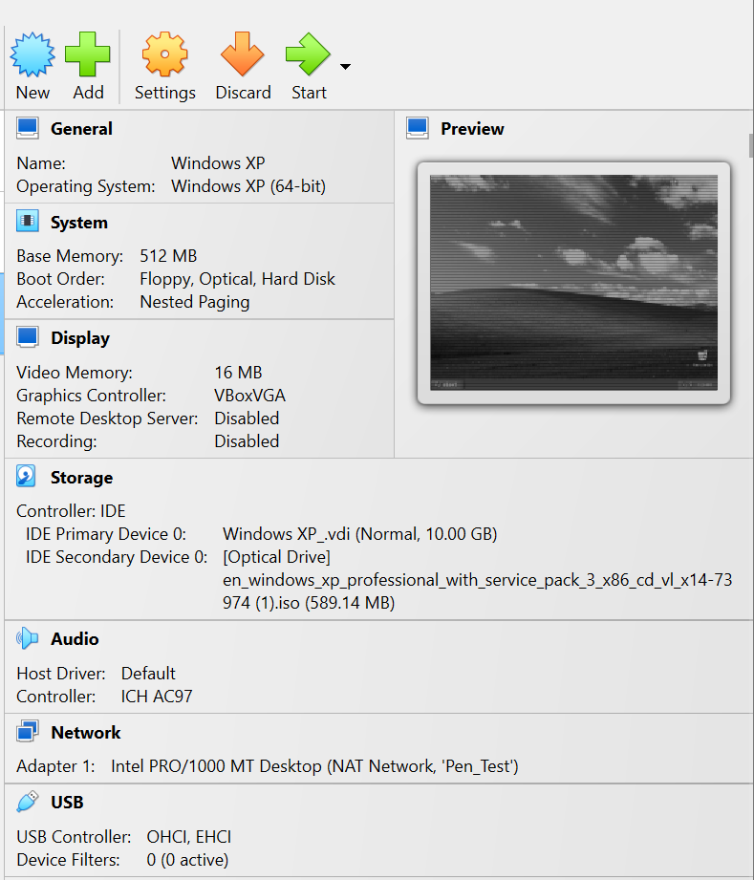

3.3 Network Configuration (NAT network)
NAT Network acts like a sealed sandbox environment. The traffic between Kali Linux (attacker) and Windows XP (victim) stays entirely within this virtual network ensuring no risk to the real network.
Bridged Adapted: It would put my VMs directly on my home network. It would be dangerous as there could be a risk of attack potentially targeting real devices on my network by accident.
Host-Only: This would isolate the VMs completely, with no internet access. Even though it is safe, it will prevent me from downloading any new tools or updates during the lab session.
Basic NAT: This ode only provides internet access to a single VM and does not allow VMs to communicate with each other, making the attack impossible.
Therefore, NAT network is the best option for virtual penetration testing environment.
Creating NAT network in VirtualBox
First, we open the VirtualBox Global Settings and then navigate as follow:
Tools Network NAT Networks Create
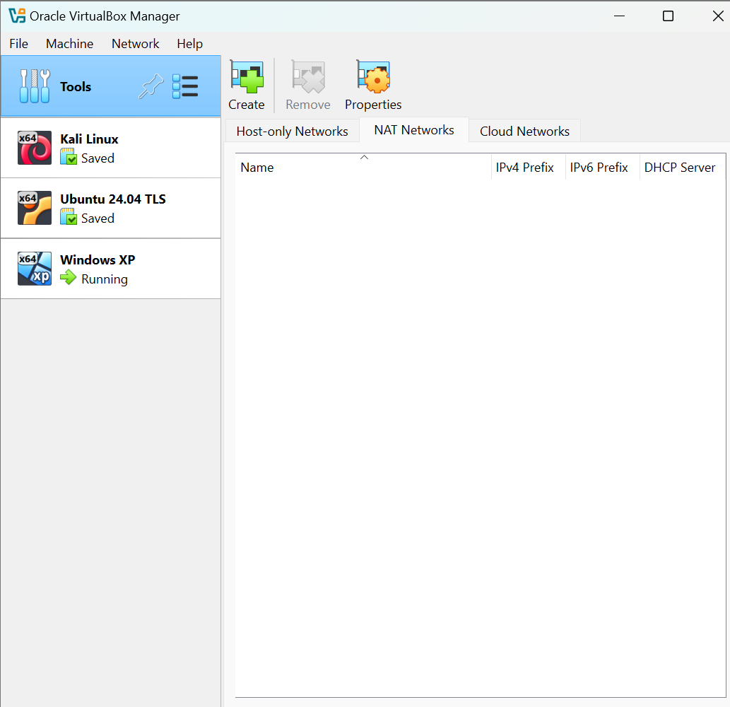
It will create a default NAT network, which we will rename to “Pen_Test”
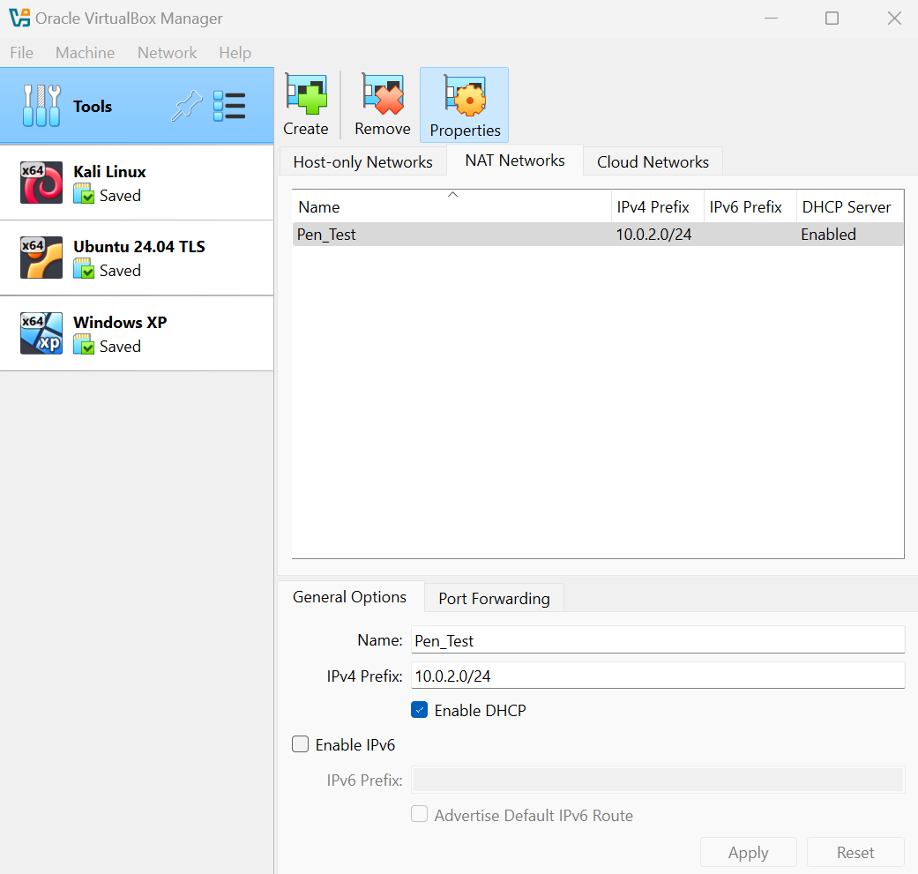
Then we attached our Kali Linux machine and Windows XP to this network, we will do this by going into their settings network Attached to (select NAT network).
Kali Linux
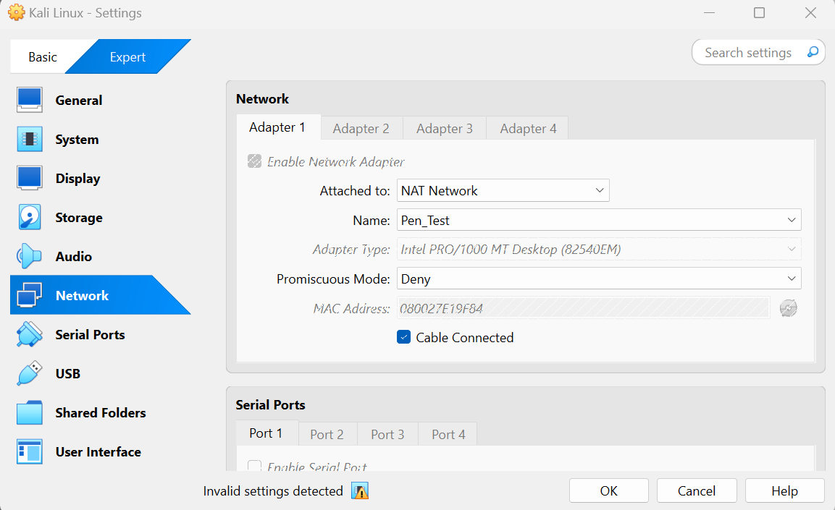
For Windows XP
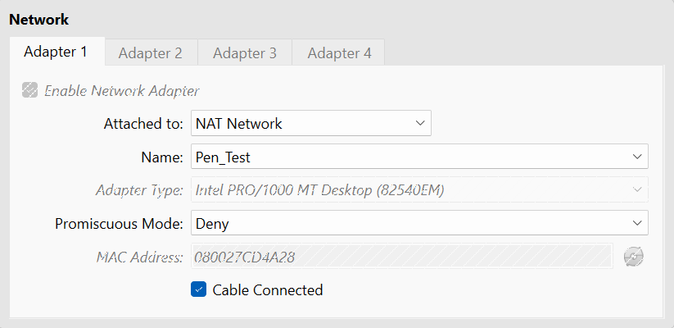
Installing Armitage on Kali Linux
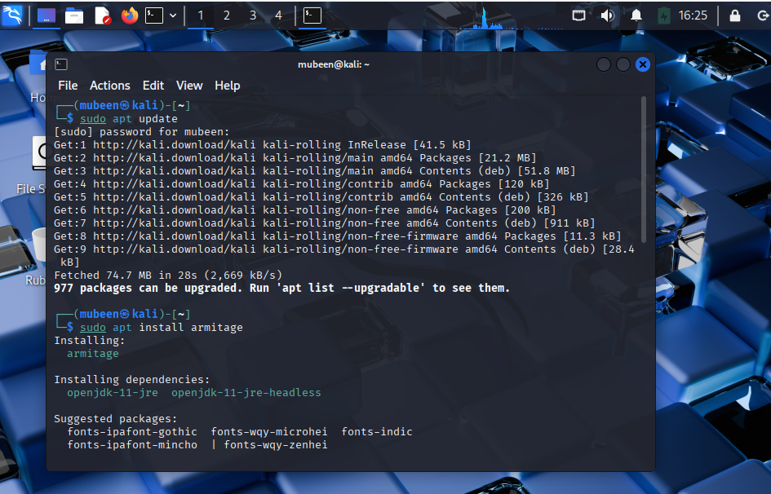
Finding the Victim and Attacker IP address
We can use “ipconfig” in the control panel CMD in windows XP to find the IP address or go to Kali Linux terminal and write “sudo nmap -sn 10.0.2.0/24”
For Kali Linux ip address, I used the command “ip a” in the terminal
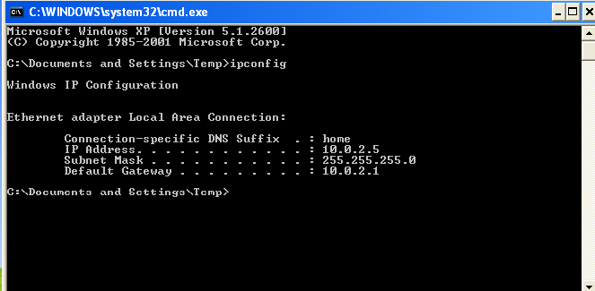
Armitage GUI
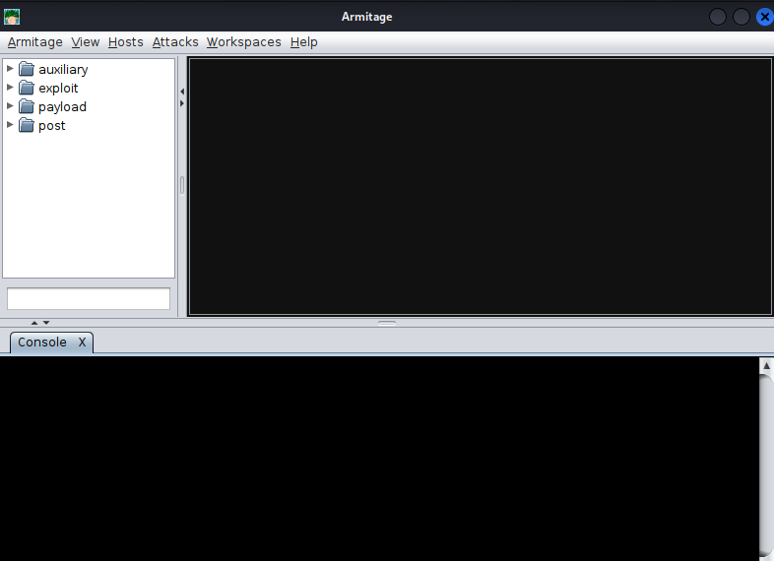

4. Methodology: The Attack Chain

4.1 Step 1: Reconnaissance
Reconnaissance is the preliminary phase of the cyberattack, it involves scanning of network, systems, or web applications to gather information about potential vulnerabilities that can be exploited.
Tool Used: Integrated NMAP scanner within Armitage GUI
Action:
First, we will go to Host Add Host and enter the Victim IP address “10.0.2.5”
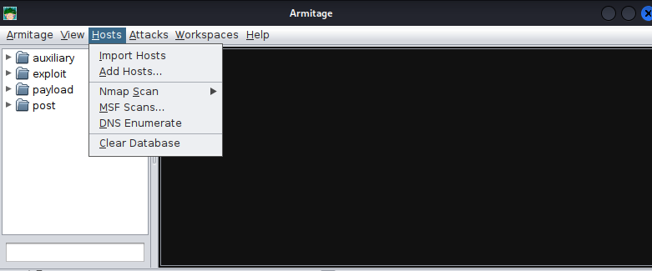
Then we will right click on the victim, click on the scan and it finds several open ports. We can see “Port 445” which is our main target as this port is vulnerable to MS08-067 NETAPI exploit.
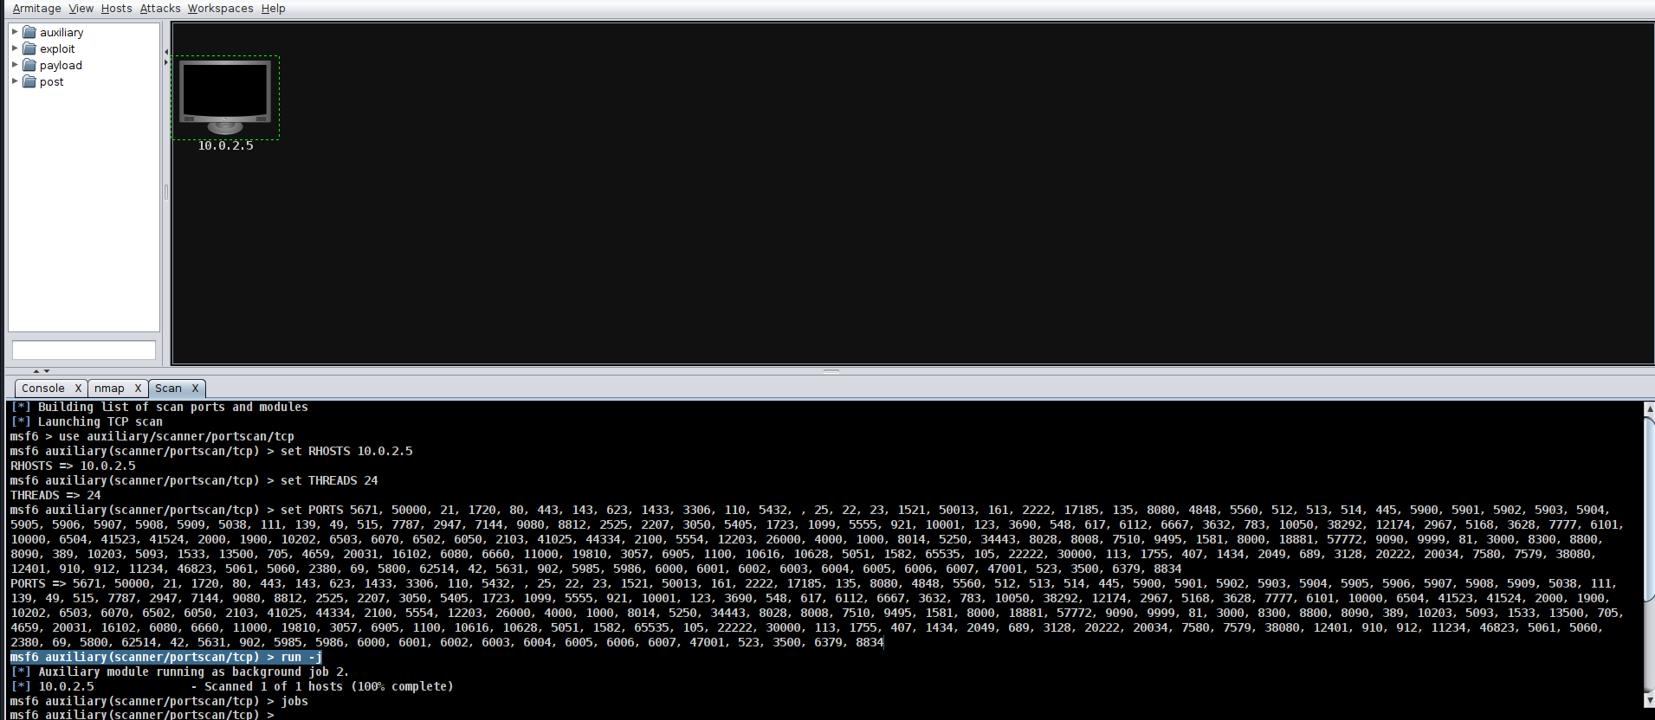

4.2 Step 2: Vulnerability Analysis
After a successful reconnaissance phase, we will now conduct vulnerability analysis.
We used Armitage “Find attacks” automation feature (Attacks Find Attacks). This will help us automatically identify and suggest suitable exploit modules that could be used against the vulnerabilities in the services running on target machine.
Our Armitage Find attacks was successful in completing vulnerability analysis which means it has found one matching exploit that is likely to work (MS08-067NETAPI)
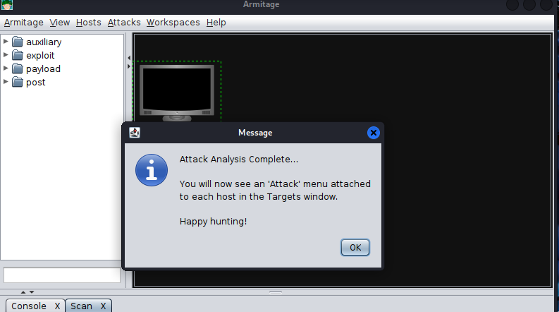

4.3 Step 3: Exploitation
The exploitation phase was initiated to gain unauthorized access to the target’s system.
We start by selecting the exploit on the left-hand panel of Armitage we see exploit. Navigate as follows: Exploit Windows SMB MS08_067NETAPI.

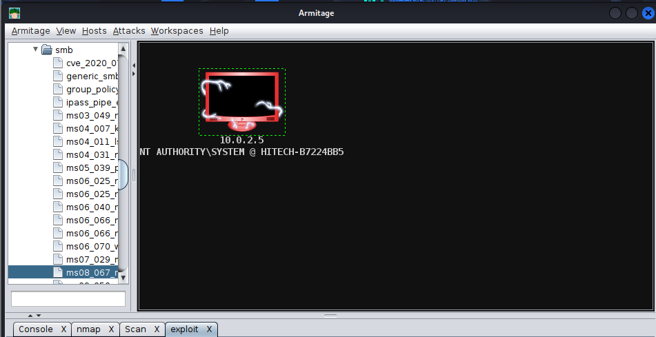
Double Click on MS08_067NETAPI
- Set LHOST: 10.0.2.4 (Kali IP)
- Set RHOST: 10.0.2.5 (Target IP)
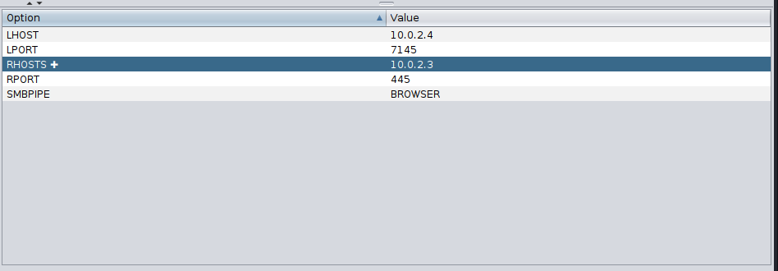
Then click on use reverse connection and launch 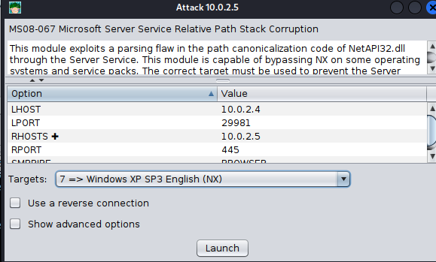

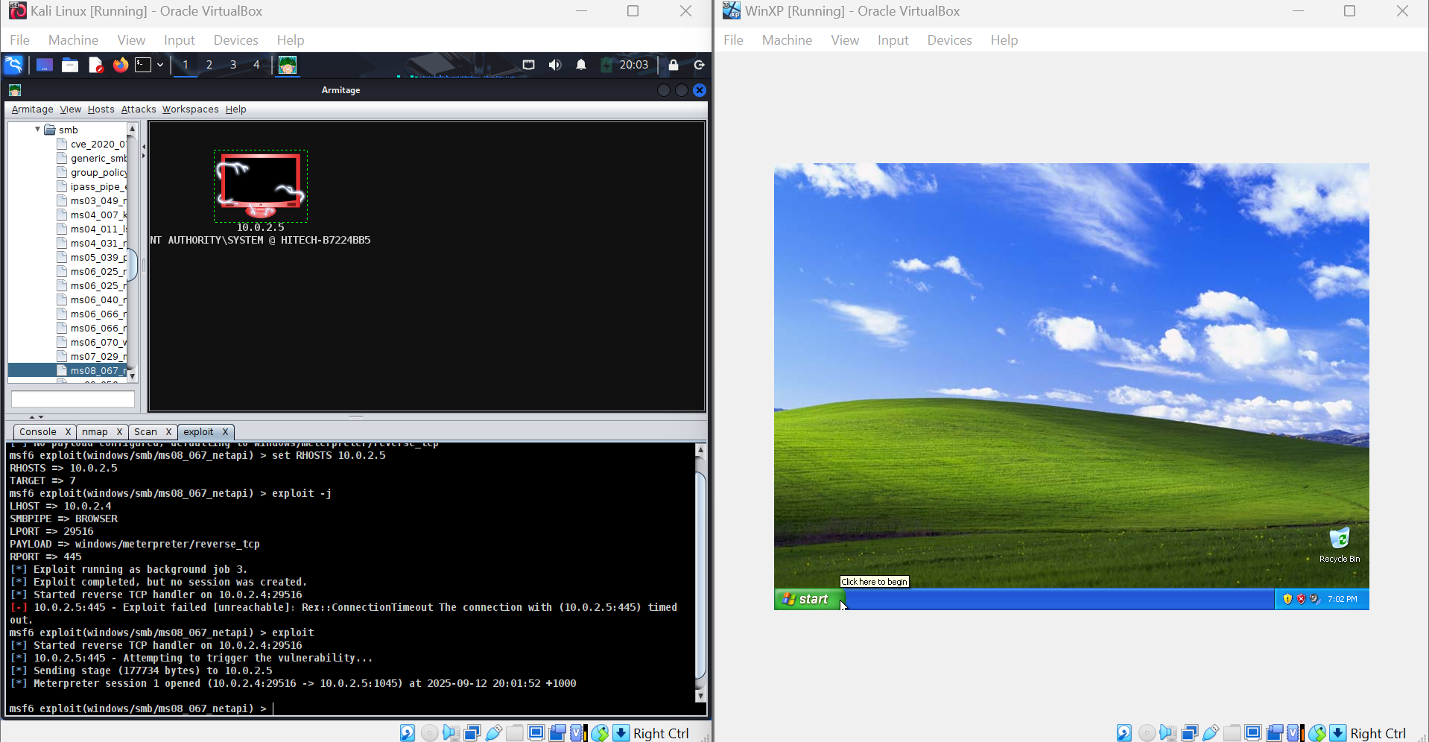
We have now successfully triggered the vulnerability on the Windows XP machine. The payload (Meterpreter) was delivered and executed.
A Meterpreter session is now open, and we have the remote-control access to Windows XP. Now we will interact with the session in POST-EXPLOITATION phase.
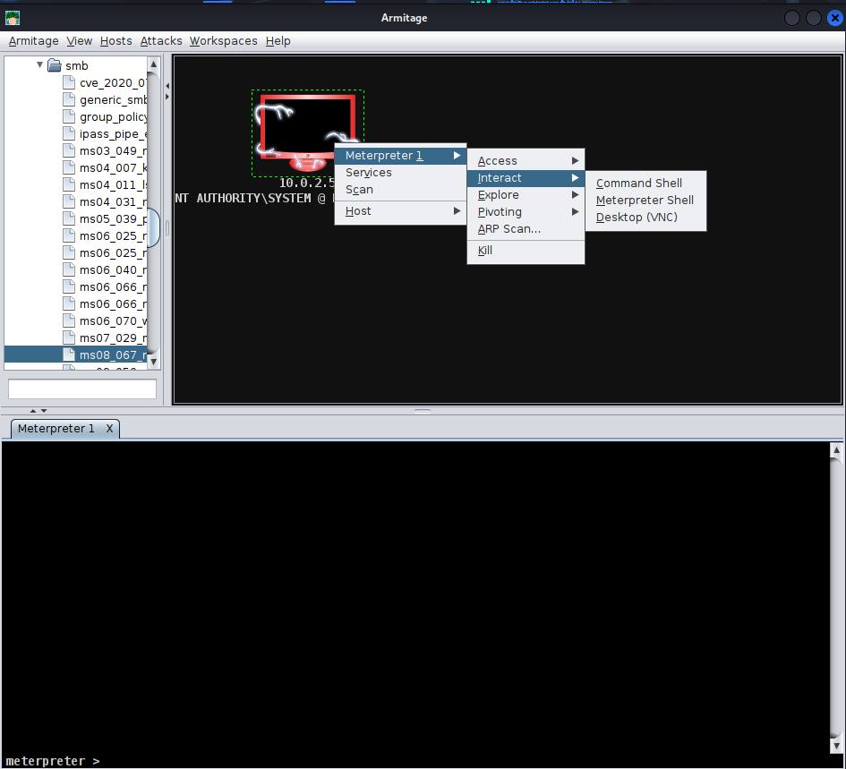

4.4 Step 4: Post-Exploitation
In this phase, we will demonstrate key post-exploitation techniques.
Activities Performed:
- System Information Gathering:
We used the command “sysinfo” within the meterpreter session to gather the details about the compromised host, confirming the control over Windows XP system.
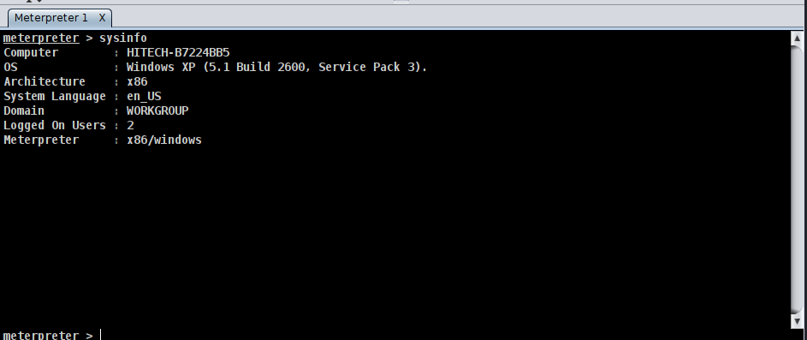
- Remote Desktop Surveillance:
“Screenshot” command was used to capture the current state of the user’s desktop remotely. It demonstrates the ability to visually monitor victim’s computer without their knowledge.

- Keylogging:
“Keylogging” command was used to begin capturing the keystrokes on the victim machines. Which highlights the risk of stealing sensitive information like passwords and credentials.
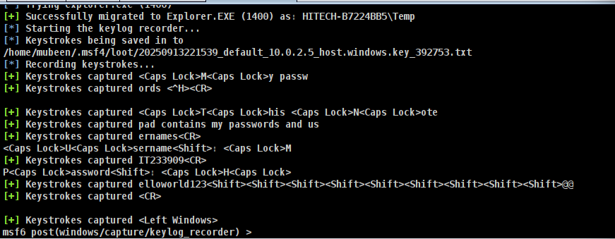
Used Browse File option to investigate all the victim files
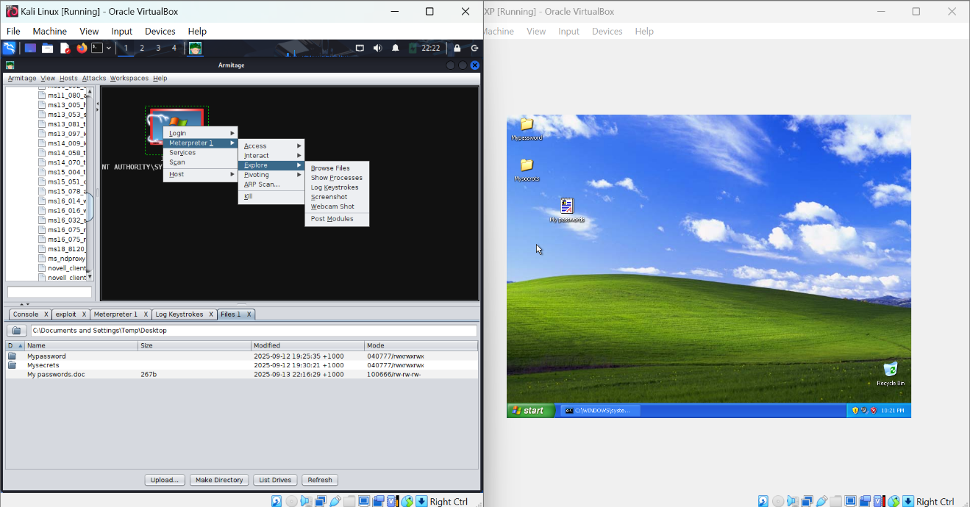

5. Results & Analysis
The exploitation of MS08-067 vulnerability was successful, resulting in a remote Meterpreter session with SYSTEM-level privileges on the Windows XP victim machine. POST-exploitation activities such as keylogging, screenshot capture, shell, file exploration shows the total compromise of confidentiality and control

6. Defense and Mitigation strategies
To defend against exploits like MS08-067, organizations must adopt a proactive security posture. Mitigation strategies include:
- Configuring Host-Based Firewalls to block unnecessary inbound traffic to high-risk services from untrusted networks.
- Implement Principle of Least Privilege, restricting users and service account permissions to minimize the impact of a compromise.
- Monitor network traffic for signatures associated with SMB exploitation attempts and block them in real-time.
- Carry out regular vulnerability assessment to identify unpatched systems and misconfigurations proactively.

7. Conclusion

7.1 Key Learnings
This practical lab developed my foundational skills in offensive security and reinforced critical defensive principles:
- Tool Proficiency: Gained hands-on experience with Armitage to automate Metasploit workflows, including NMAP scanning, vulnerability analysis, and exploit execution.
- Exploit Development: Understood the process of leveraging a known vulnerability to achieve remote code execution.
- Post-Exploitation Technique : Practice essential techniques including privilege escalation, remote desktop surveillance, and user activity monitoring.
- Troubleshooting: Developed problem-solving skills by diagnosing network issues, exploit failures- simulating real-world penetration testing challenges.

7.2 Ethical Hacker’s mindset
The core of ethical hacking is offensive knowledge for defensive purposes. This lab reinforced the mindset that to defend a system, one must first learn how to attack it. This approach is grounded in a responsibility to protect, requiring strict adherence to legal and ethical boundaries, transparency, and a commitment to using skills to improve security posture rather than to cause harm.

